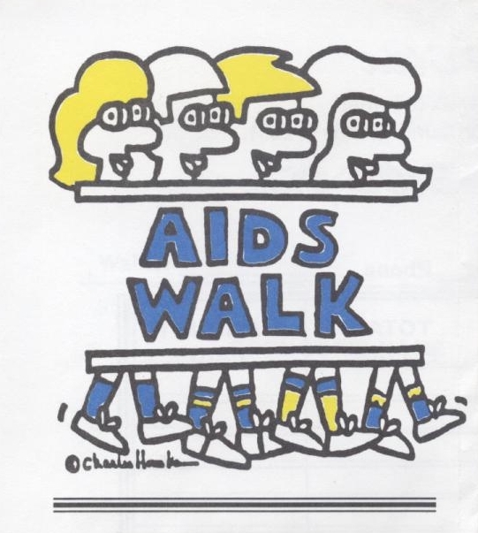
AIDS remains one of the leading causes of death for individuals between the ages of 25 and 44 in this country. The good news about AIDS treatments means your support of AIDS services in Springfield is more important than ever. We now have more people needing the services of AIDS organizations than at any time in the history of this epidemic.



WHY?

There is a great need to help those who are HIV infected and living with AIDS. There are more people than ever before who are living with AIDS and they need your help. Every donations and every walker is important. The purpose of the walk is to raise dollars to provide housing for people living with AIDS in Springfield, as well as providing support servides, education and prevention programs. Just as importantly, the walk will raise awareness about AIDS and how it is affecting Springfield.

HOW?

Become a sponsored walker by asking your friends, relatives and co-workers to sponsor you and set a goal of at least $10 per person.

WHEN & WHERE?

Sunday, May 2, 2004

Registration Starts

At 11:00 a.m.

THE WALK BEGINS PROMPTLY AT 3:00PM AT THE OLD STATE CAPITOL PLAZA IN SPRINGFIELD AND WILL END AT THE SAME LOCATION.

LIVE ENTERTAINMENT!

BEFORE AND AFTER THE WALK

AIDS
WALK
2003

The Tenth
Annual
AIDS Walk
Springfield

May 4th, 2003

